1. Demonstrate that you have created MySQL instance

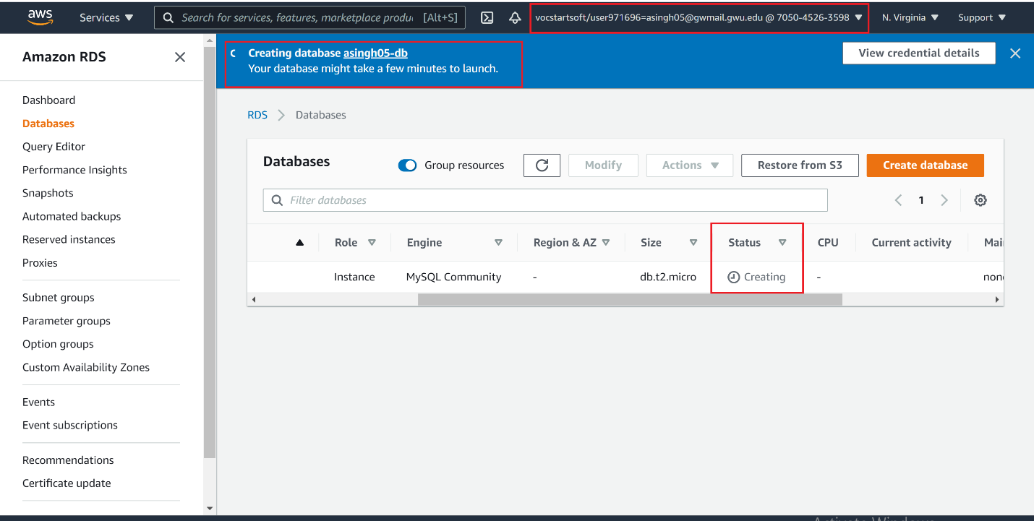

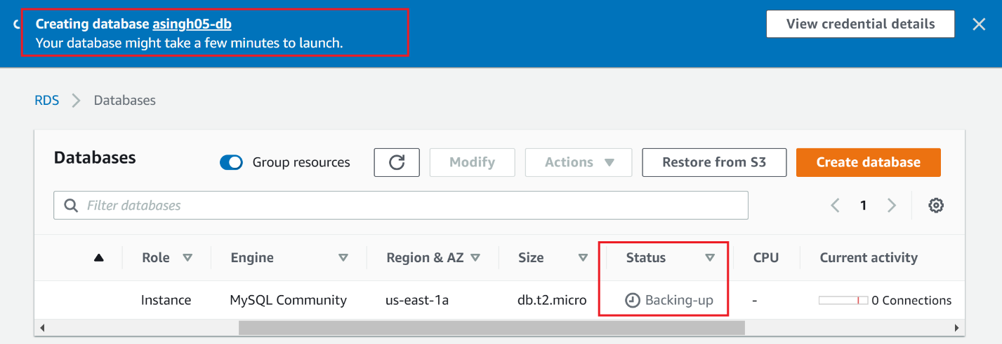

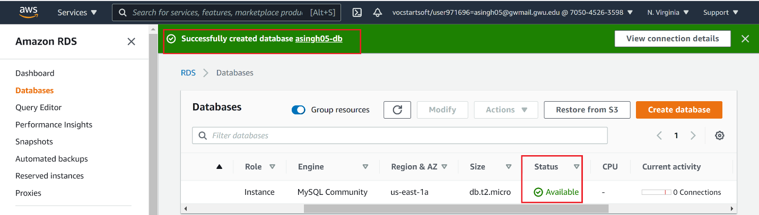

2. Demonstarte that you have loaded hr and northwind schemas into MySQL Workbench

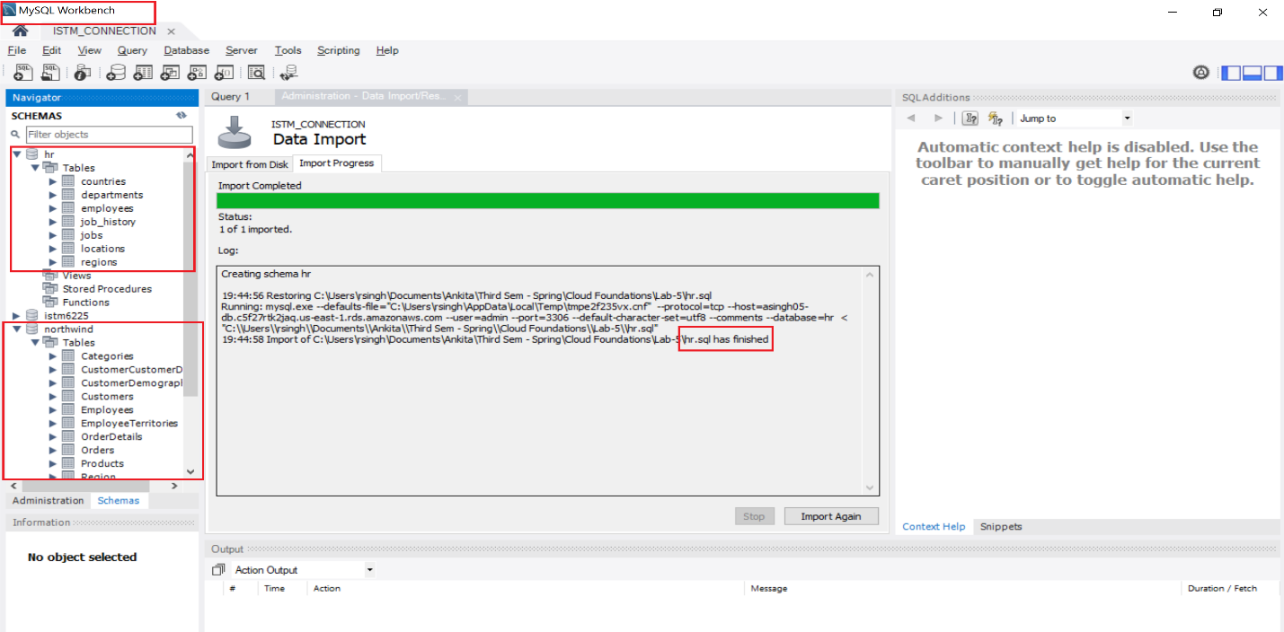

3. Write a query to show minimum salary paid to employees - demonstrate output

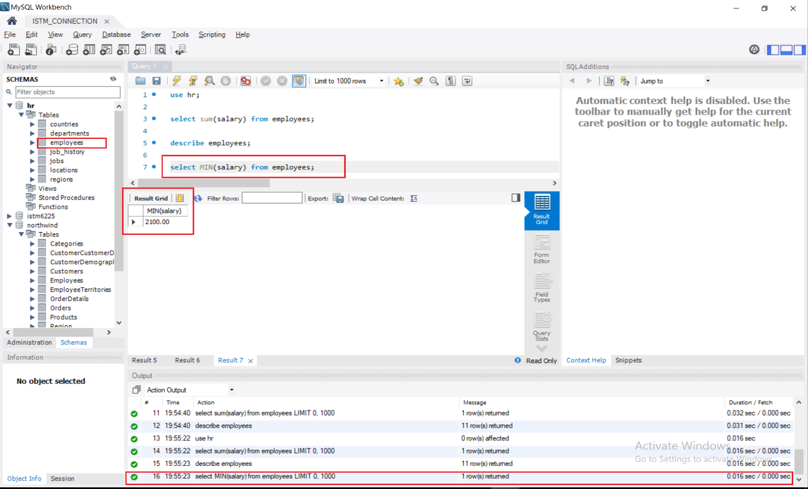

4. Query the Peopel table - demonstrate output

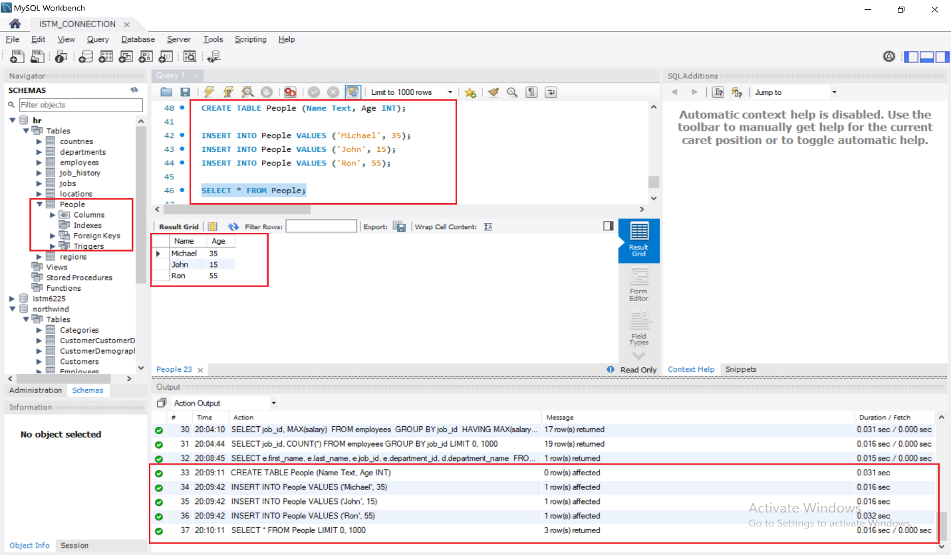

5. Query to show salary differences between highest and loweset salaries (step 6)

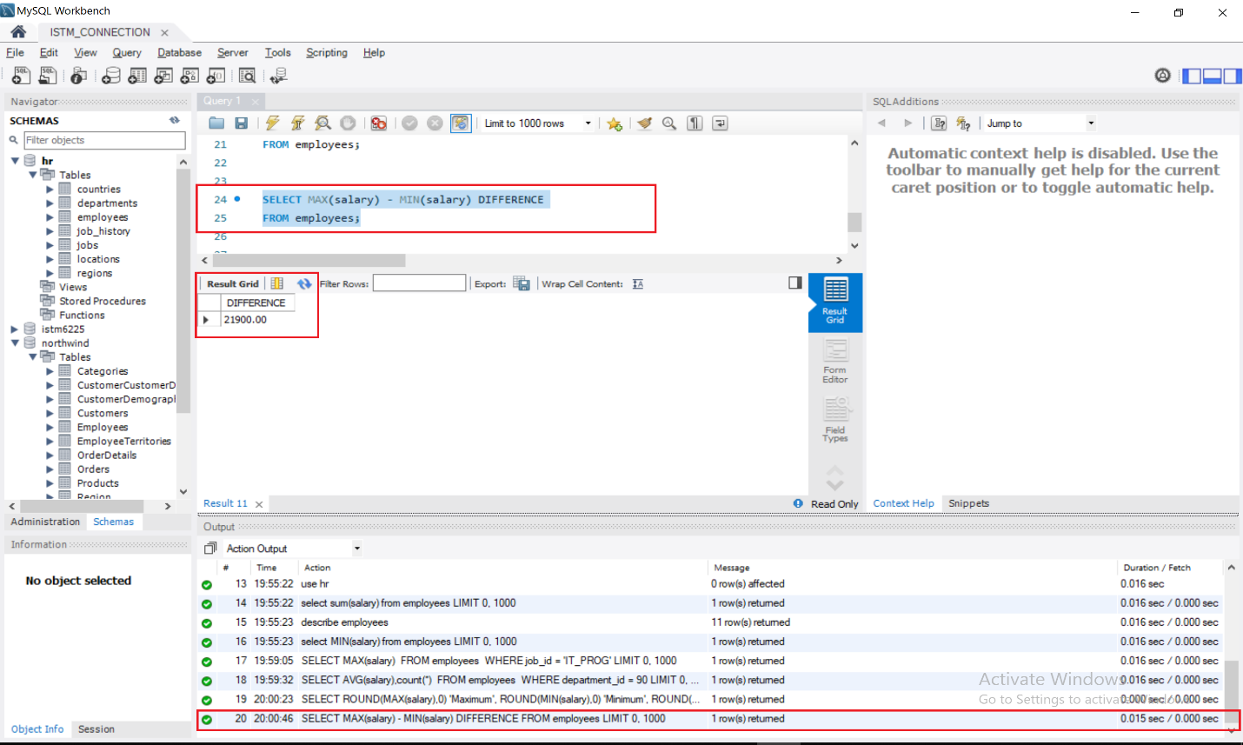

6. Query to show list of employees who have the same job (Step 9)

